ECAO3O5- SIGNALS AND SYSTEMS
NAME: S.GOKUL
REG NO: 192512373

Experiment No.: 5
Title: Fourier Series Analysis of Periodic Signals
Objective (i) To analyze Fourier series of continuous-time periodic signals and analyze their waveform Characteristics.
AIM
To analyze the Fourier series of a continuous-time periodic signal (half-wave rectified sinusoid) and study its waveform characteristics using MATLAB.
APPARATUS / SOFTWARE REQUIRED
1. Computer / Laboratory PC
2. MATLAB software (with Signal Processing environment)
THEORY
A periodic signal x(t) with fundamental period T₀ that satisfies the Dirichlet conditions can be represented as the sum of a DC term and harmonically related sinusoids. This is called the trigonometric Fourier series, and its coefficients are obtained by integrating the signal over one complete period.
The half-wave rectified sinusoid x(t) = max[A sin(2πf₀t), 0] is used in this experiment. Its series contains a DC term A/π, a fundamental sine term (A/2) sin(ω₀t), and cosine terms only at even harmonics; the other odd harmonics are absent. When the series is truncated to N harmonics, the reconstruction approaches the original waveform, with a small ripple (Gibbs phenomenon) near the sharp transitions.
FORMULAE USED
x(t) = a₀/2 + Σ [aₙ cos(nω₀t) + bₙ sin(nω₀t)]
ω₀ = 2πf₀, T₀ = 1/f₀
aₙ = (2/T₀) ∫ x(t) cos(nω₀t) dt; bₙ = (2/T₀) ∫ x(t) sin(nω₀t) dt (over one period)
Half-wave rectified sinusoid: a₀/2 = A/π, b₁ = A/2, aₙ = −2A / [π(n² − 1)] for even n
ALGORITHM / PROCEDURE
- Start MATLAB and define the amplitude A, fundamental frequency f₀, period T₀ and the time vector.
- Generate the half-wave rectified sinusoidal periodic signal x(t).
- Compute the Fourier coefficients a₀, aₙ and bₙ up to N = 10 harmonics using numerical integration (trapz) over one period.
- Construct the Fourier-series approximation using the calculated coefficients.
- Plot the original signal and the reconstructed signal on the same axes with title, labels, grid and legend.
- Compare the two waveforms and note the effect of the harmonics on the reconstruction.
INPUT PARAMETERS
S.No. | Input Parameter | Symbol / Setting | Value | Unit
1 | Signal amplitude | A | 1 | —
2 | Fundamental frequency | f₀ | 1 | Hz
3 | Fundamental period | T₀ | 1 | s
4 | Number of harmonics | N | 10 | —

PROGRAM (MATLAB CODE)
clc; clear; close all;
%% 5(i) Analysis of Fourier Series Representation of Continuous-Time Periodic Signals
figure;
% Fourier Series Representation of a Periodic Signal
A = 1;
f0 = 1;
T = 1/f0;
t = linspace(0, 2*T, 2000);
% Half-wave rectified sinusoidal signal
x = A*sin(2*pi*f0*t);
x(x < 0) = 0;
N = 10;
% Coefficients are calculated over one complete period (0 to T)
idx = t <= T;
a0 = (2/T)*trapz(t(idx), x(idx));
an = zeros(1,N);
bn = zeros(1,N);
for k = 1:N
an(k) = (2/T)*trapz(t(idx), x(idx).*cos(2*pi*k*f0*t(idx)));
bn(k) = (2/T)*trapz(t(idx), x(idx).*sin(2*pi*k*f0*t(idx)));
end
xFS = (a0/2)*ones(size(t));
for k = 1:N
xFS = xFS + an(k)*cos(2*pi*k*f0*t) ...
+ bn(k)*sin(2*pi*k*f0*t);
end
plot(t,x,'k','LineWidth',1.2); hold on;
plot(t,xFS,'r--','LineWidth',1.2);
grid on;
xlabel('Time (s)'); ylabel('Amplitude');
title('Fourier Series Representation of a Periodic Signal');
legend('Original Signal','Fourier Series Reconstruction');
OUTPUT
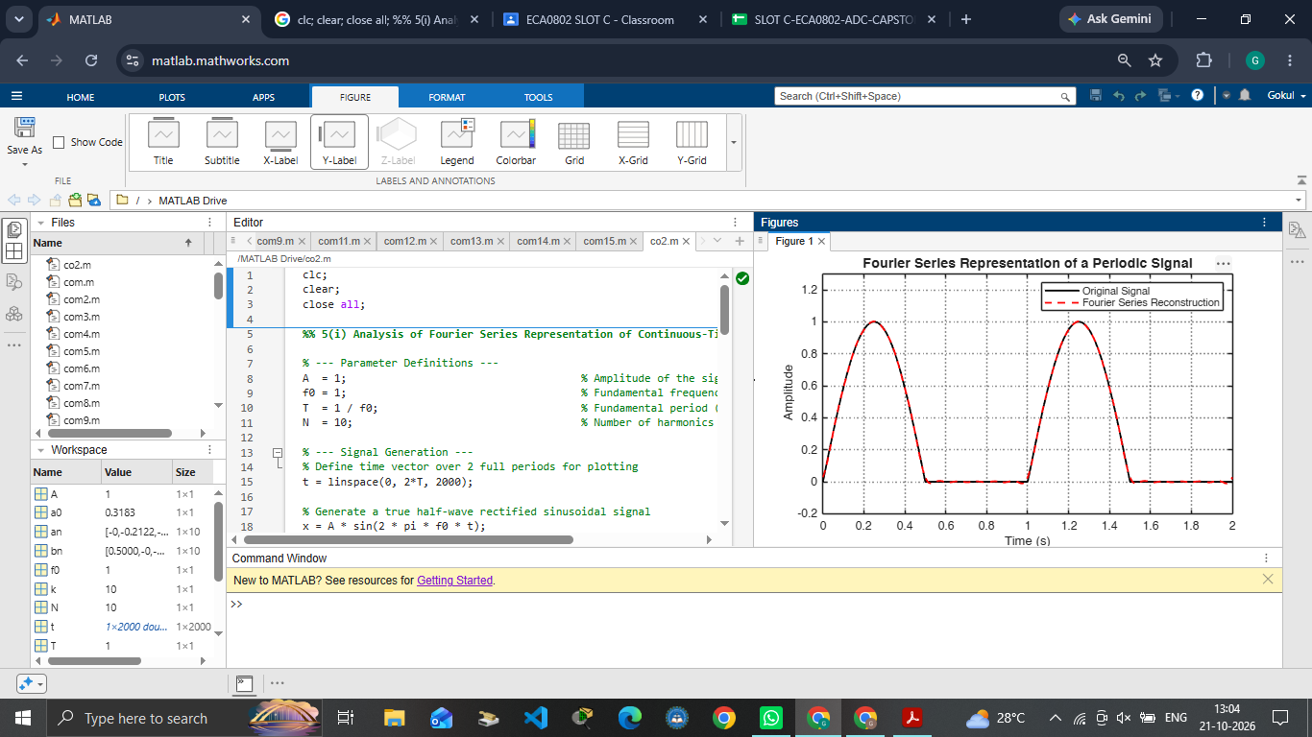
Fig. 5.1 Original half-wave rectified sinusoid and its 10-harmonic Fourier-series reconstruction
OUTPUT PARAMETERS (THEORETICAL vs SIMULATED)
S.No. | Output Parameter | Theoretical Value | Simulated Value | % Deviation
1 | DC coefficient a₀/2 | 1/π = 0.3183 | 0.3183 | ≈ 0 %
2 | Coefficient b₁ | 0.5000 | 0.5000 | ≈ 0 %
3 | Coefficient a₂ | −2/(3π) = −0.2122 | −0.2122 | ≈ 0 %
4 | Harmonic count | 10 | 10 | Exact
5 | Original vs reconstructed waveform | Fourier approximation | Plots coincide; ripple at transitions | Qualitative match

RESULT
The Fourier series of the half-wave rectified sinusoid was obtained using 10 harmonics. The computed coefficients (a₀/2 = 0.3183, b₁ = 0.5, a₂ = −0.2122) agree with the theoretical values, and the reconstructed waveform follows the original signal closely, with a small ripple (maximum deviation about 0.03) only near the sharp transitions.

Objective (iv) To reconstruct periodic signals using Fourier series and verify the reconstructed waveform with the original signal.
AIM
To reconstruct a periodic signal using its Fourier series and verify the reconstructed waveform against the original signal using MATLAB.
APPARATUS / SOFTWARE REQUIRED
1. Computer / Laboratory PC
2. MATLAB software (with Signal Processing environment)
THEORY
A periodic signal can be reconstructed from its Fourier coefficients by adding the DC term and the harmonic components. With a finite number N of harmonics the reconstructed signal x_r(t) is only an approximation of the original x(t).
The reconstruction error e(t) = x(t) − x_r(t) is small over the smooth parts of the waveform and largest near discontinuities and sharp transitions (Gibbs phenomenon). The error decreases as more harmonics are included. The coefficients must be computed over one complete period so that the reconstructed signal preserves the periodicity of the original.
FORMULAE USED
x_r(t) = a₀/2 + Σ [aₙ cos(nω₀t) + bₙ sin(nω₀t)], n = 1 to N
Reconstruction error: e(t) = x(t) − x_r(t)
Percentage deviation = |Practical − Theoretical| / |Theoretical| × 100
ALGORITHM / PROCEDURE
- Start MATLAB and generate the half-wave rectified sinusoid over two periods (0 to 2T₀).
- Compute the Fourier coefficients a₀, aₙ and bₙ (n = 1 to 10) from one period of the signal.
- Construct the reconstructed signal x_r(t) using 10 harmonics.
- Calculate the error signal e(t) = x(t) − x_r(t).
- Plot the original and reconstructed signals, and the reconstruction error, using subplot.
- Observe the error near the transitions and record the result.
INPUT PARAMETERS
S.No. | Input Parameter | Symbol / Setting | Value | Unit
1 | Fundamental frequency | f₀ | 1 | Hz
2 | Number of harmonics | N | 10 | —
3 | Time duration | 2T₀ | 2 | s
4 | Signal | x(t) | Half-wave rectified sinusoid | —

PROGRAM (MATLAB CODE)
clc; clear; close all;
%% 5(iv) Verification of Fourier Series Reconstruction and Analysis of Signal Characteristics
figure;
% Fourier Series Reconstruction and Error Analysis
f0 = 1;
T = 1/f0;
t = linspace(0,2*T,4000);
x = max(sin(2*pi*f0*t),0);
N = 10;
a0 = (2/T)*trapz(t(1:2000),x(1:2000));
an = zeros(1,N); bn = zeros(1,N);
tt = t(1:2000); xx = x(1:2000);
for k = 1:N
an(k) = (2/T)*trapz(tt,xx.*cos(2*pi*k*f0*tt));
bn(k) = (2/T)*trapz(tt,xx.*sin(2*pi*k*f0*tt));
end
xr = a0/2*ones(size(t));
for k = 1:N
xr = xr + an(k)*cos(2*pi*k*f0*t) + bn(k)*sin(2*pi*k*f0*t);
end
err = x-xr;
subplot(2,1,1);
plot(t,x,'k',t,xr,'r--','LineWidth',1.1);
grid on; xlabel('Time (s)'); ylabel('Amplitude');
title('Original and Reconstructed Signals');
legend('Original','Reconstructed');
subplot(2,1,2);
plot(t,err,'b'); grid on;
xlabel('Time (s)'); ylabel('Error');
title('Reconstruction Error');
OUTPUT
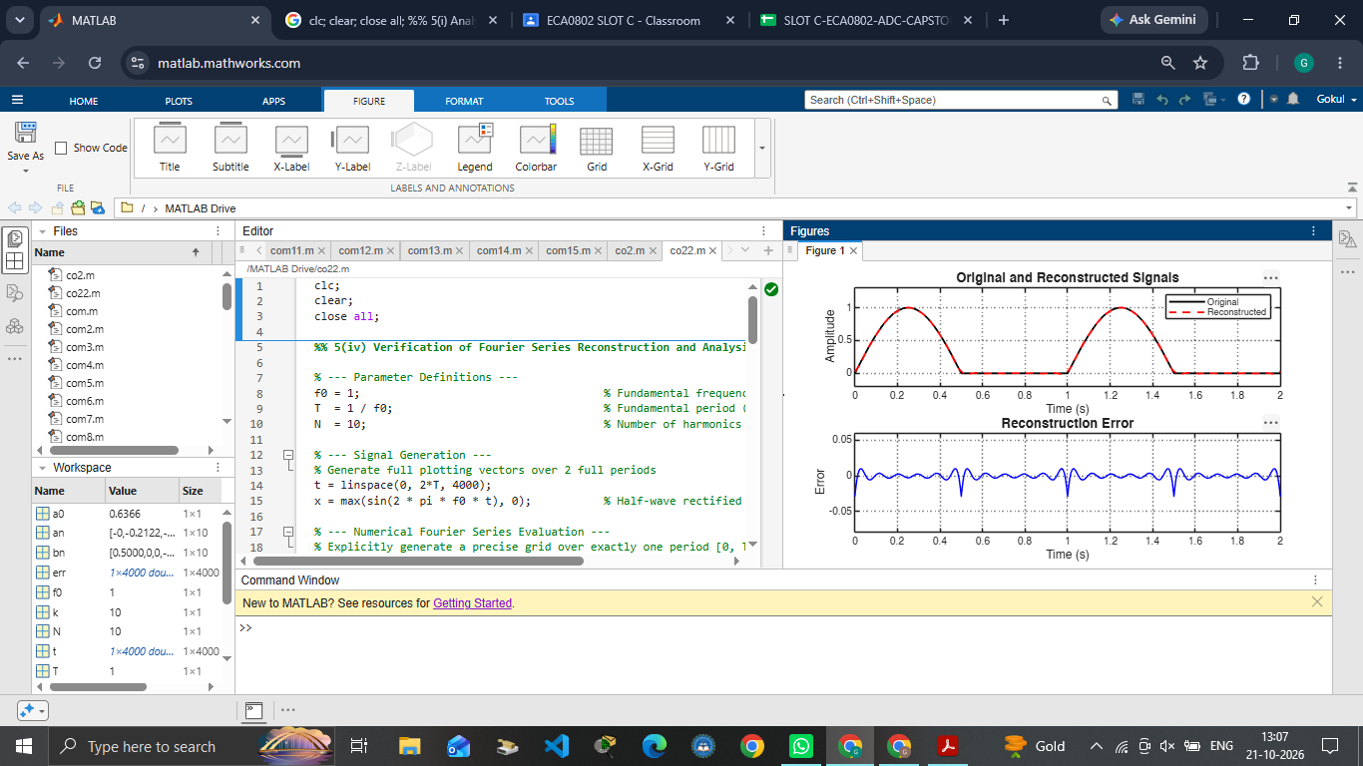
Fig. 5.2 Original and reconstructed signals, and the reconstruction error
OUTPUT PARAMETERS (THEORETICAL vs SIMULATED)
S.No. | Output Parameter | Theoretical Value | Simulated Value | % Deviation
1 | Reconstructed signal | Fourier approximation | Follows original signal | Qualitative match
2 | Reconstruction error | Small | Max |e(t)| ≈ 0.029 (at transitions); ≈ ±0.01 elsewhere | Small error
3 | Harmonic count | 10 | 10 | Exact
4 | Signal period | 1 s | 1 s | 0 %

RESULT
The half-wave rectified sinusoid was reconstructed using its first 10 Fourier harmonics and compared with the original signal. The reconstructed waveform closely matches the original; the reconstruction error is small, with a maximum magnitude of about 0.029 occurring at the transition points and within about ±0.01 over the rest of the waveform.

LABORATORY PERFORMANCE ASSESSMENT RUBRICS:

Objective | Assessment Criterion | Excellent – 4 | Good – 3 | Satisfactory – 2 | Needs Improvement – 1 | Weightage | Marks(10) | Marks obtained
(i) To analyze the Fourier series of continuous-time periodic signals and analyze their waveform characteristics. | Fourier Series Analysis | Correctly determines the fundamental period and frequency and computes the Fourier coefficients for every given periodic signal, analytically or in MATLAB. Uses suitable commands with correct limits and obtains accurate coefficient values. | Computes the coefficients for most signals correctly, with minor errors in limits, algebra, code or parameters. | Computes the coefficients for only some signals, or has noticeable errors in integration, limits or code, and needs guidance. | Unable to compute the Fourier coefficients of the given signals. | 20 | 2
 | Waveform Characteristics & Spectrum Analysis | Correctly identifies symmetry (even, odd, half-wave), DC value and the harmonics present. Plots the amplitude and phase spectra with titles, axis labels and grid. Explains how symmetry and the shape of the waveform determine the harmonic content and the rate of decay of the coefficients. | Identifies most waveform characteristics and plots the spectra correctly, with minor errors or limited explanation. | Identifies basic characteristics. Spectra have noticeable errors or the explanation is incomplete, and needs guidance. | Unable to identify the waveform characteristics or plot the spectra. | 20 | 2
(ii) To reconstruct periodic signals using the Fourier series and verify the reconstructed waveform with the original signal. | Signal Reconstruction using Fourier Series | Correctly synthesizes each periodic signal as a partial sum of N harmonics in MATLAB, using a suitable time vector and loop or vectorized code. Reconstructs with several values of N and plots them clearly against the original. | Reconstructs the signals correctly with minor errors in code, time range, parameters or labelling, and uses fewer values of N. | Reconstructs only some signals or uses a single value of N, with noticeable errors in code or plots, and needs assistance. | Unable to reconstruct the signals using the Fourier series. | 20 | 2
 | Verification of Reconstructed Waveform | Verifies the reconstruction against the original waveform using overlay plots and numerical error for each N. Shows that the error decreases as N increases, and identifies the Gibbs phenomenon at discontinuities with a correct explanation. | Verifies the reconstruction with overlay plots and some error measure, with minor errors in calculation or interpretation of convergence. | Performs basic visual comparison only, with noticeable errors or no numerical error. Convergence or Gibbs phenomenon is not explained, and needs guidance. | Unable to verify the reconstructed waveform against the original signal. | 20 | 2
Interpret the Fourier series results and maintain the record. | Engineering Analysis, Record & Interpretation | Provides technically accurate interpretation of the results, relating the number of harmonics, symmetry and discontinuities to reconstruction accuracy. Maintains a complete, well-organized record with code, plots, observations and conclusions. | Maintains a proper record with mostly accurate interpretation, with minor omissions in observations or conclusions. | Record and interpretation are basic or partly incomplete, with limited technical reasoning. | Incomplete record, limited or incorrect interpretation of the results. | 20 | 2
 |  |  |  |  | Total | 100 | 10

